SOURCE 1

The Big 3 leaders shown in the cartoon are (left to right) President Wilson of the USA, Clemenceau of France and Prime Minister Lloyd George of Britain. They are standing around a guillotine (an old French execution apparatus) and are focusing on a figure before them.

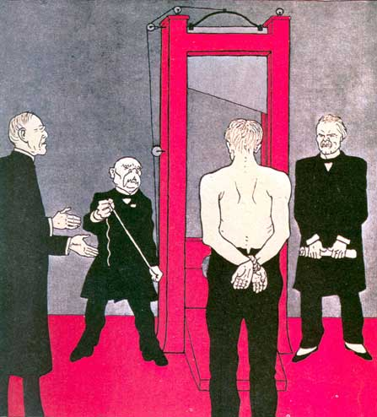

A cartoon published in the German magazine Simplissimus, June 1919

